**Module 3: IAM Roles Assignment**

**Tasks To Be Performed:**

1. Create a role which only lets user1 and user2 from task 1 to have complete

access to VPCs and DynamoDB.

2. Login into user1 and shift to the role to test out the feature.

Go to IAM dashboard🡪 roles 🡪create role

Now on clicking on create role new popup will open.

Here we will go with custom policy , lets copy the arn of the user before..

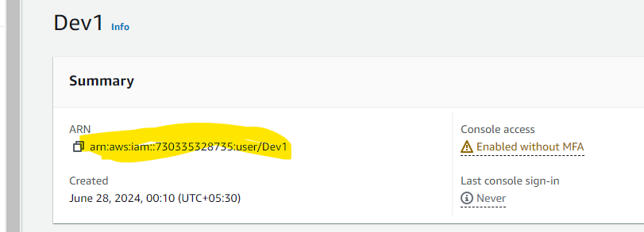

Now in custom policy

We have add the arn of both the users here.

Now next step is permissions. We have to give full permissions to VPC and dynamo DB.

Give a name and create it.

Now lets login with our IAM user.

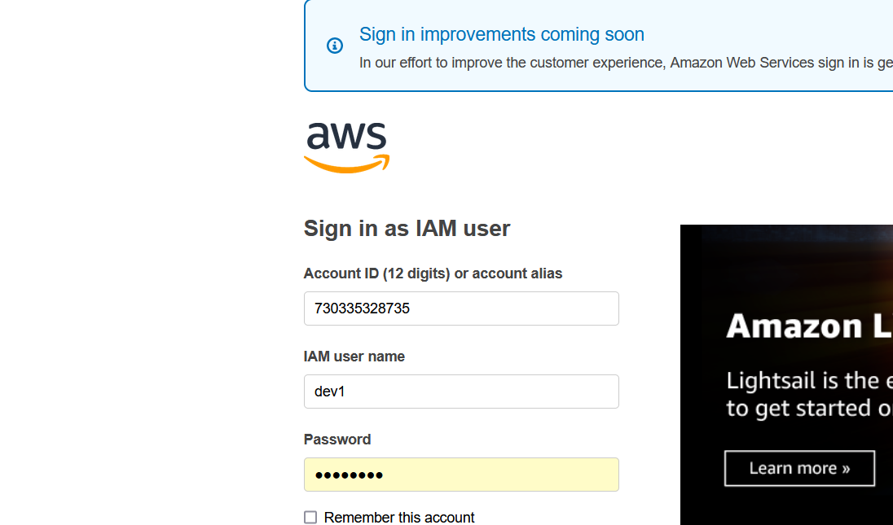

Now from the top right side click on your user and switch role

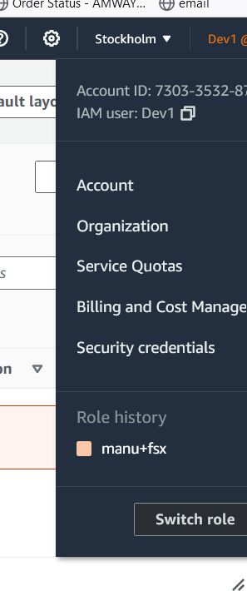

Search for our role we created and fill the details

Click on switch role and go in vpc now. And we can see no errors.

